Road to Survival Design Document

Daniel Levinthal

Shaohang Song

Zachary Lund

Francisco Valdez

Cole Weitzel

Arizona State University

CPI211: Game Development II

Justin Selgrad

25 March 2022

**Table of Contents**

Changes……………………………………………………………………………………Page 2

2 Sentence Pitch, 2 Minute Pitch …..……………………………………………………..Page 3

Gameplay Overview………………………………………………………………………Page 5

*Movement and Camera control:*…………………………..………………………Page 5

*Aiming and firing your weapon:*…………………………..………………………Page 5

*Collectables:*………………………………..……………………………………..Page 5

*Opening Chests:* …………………………..……………………………….……...Page 5

*Opening Doors:* …………………………..……………………………………….Page 5

*Changing your currently equipped weapon:*………………………………………Page 6

*Types of weapons:* ………………………..………………………………………..Page 6

*Death Mechanics:* ………………………..………………………………………..Page 6

Environment and Level Design Overview............................................................................Page 6

Art Direction and Documentation.........................................................................................Page 7

UI/Menus...............................................................................................................................Page 9

Enemy Overview...................................................................................................................Page 10

Timeline and Milestones.......................................................................................................Page 11

Team Bio and Expected Contribution Field..........................................................................Page 13

Post-Mortem..........................................................................................................................Page 15

Credits……...........................................................................................................................Page 17

## **Changes**

## Acquired various art assets

* + Low poly dungeon environments
  + Weapons (bow, staff, crossbow, gun)
  + Enemies (skeletons, spiders, worms)
* Created version 1.0 of the design document
* Began creation of first-person camera controller for the player
* Finished the game (that was easy)

## 

## 

## 

## 

## 

## 

## **Two sentence pitch:**

A first-person shooter/adventure-style game where you must escape from a perilous dungeon created by a terrifying monster. Armed with nothing but your will to survive, you must retrieve your lost weapons and collect treasure before taking on the boss to achieve victory.

**Two Minute pitch:**

You, a lonesome adventurer, awaken inside of an ancient labyrinthian-style dungeon. The only thing you remember is the monster that likely awaits you at its end. With nothing in your possession, you must navigate your way through enemy-filled rooms and corridors to find weapons and treasures to aid you in your escape. Luckily for you, some poor adventurers must have left their equipment behind in the chests located throughout the dungeon. Acquire bows, magic, and even firearms to fend off evil monsters and undead in an attempt to reach the exit and survive. But beware, the monster waiting at the end of the dungeon remembers you too.

* Engaging in combat:
  + No one wants to get close to a scary monster, that's why your primary method of combat is through projectiles.
  + All weapons can be aimed and fired using the mouse. All weapons will shoot their respective projectile using the left click, damaging any enemy that it makes contact with. The player will have a reticle in the center of their screen to show where they are aiming at all times, you never know when a skeleton is around the corner.
  + All weapons are acquired via large treasure chests located throughout the dungeon. Each of the various weapons will have different fire rates and damage numbers respectively. The three main types of weapons are magical staffs, bows, and firearms.
* Treasure Hunting:
  + Weapons aren’t the only thing you can find in chests. You can also discover gold bars that will raise your total amount of currency acquired.
  + Gold bars will always be located inside of small chests and will serve as the secondary reward for completing challenges alongside new weapons.
  + While no equipment or items can be purchased using gold during your playthrough, you will be given a rank upon completion relative to the amount of currency you amassed during your playthrough. (ala Mama Luigi's hotel)
* Gameplay Loop:
  + Each weapon will have a unique style of combat that will ideally allow for a customizable gameplay experience. This, alongside your endgame score being based on currency as opposed to completion time, should allow for the player to tackle the game with their own preferred playstyle.
  + You can also have multiple weapons equipped at once and be able to shift between them on the fly using the numbers on the keyboard.
  + The only enemy that is required to be defeated for completion is the final boss. This means that difficult challenges can be ignored if the player so chooses, however they may miss out on a much more powerful weapon.
* Enemy Variety:
  + The various enemies in the game will have unique methods for attacking the player, keeping them on guard at all times.
    - Sword-wielding skeletons will attempt to close the gap between them and the player and deal with a devastating physical attack.
    - Tiny spiders will attempt to scurry towards the player at lightning-fast speeds.
    - Different sized variants of enemies can appear with larger/smaller health pools respectively.

## 

## **Gameplay Overview:**

*Movement and Camera control:*

* All controls related to player movement will be conducted using WASD. ‘W’ will move the player forward, ‘A’ will move them left, ‘S’ will move them back, and ‘D’ will move them to the right.
* The camera will be controlled using the mouse to look around from the first-person perspective.

*Aiming and firing your weapon:*

* The player will have a target reticle in the center of their screen that will follow the camera as they move its location using the mouse.
* When the player presses left click on the mouse, they will fire their currently equipped weapon at the location of their reticle at that moment.
* Pressing right click will aim in the currently equipped weapon (potentially may be used for alternative shots for the various weapons)

*Collectables:*

* Throughout the level, the player can collect gold bars which function as the game’s main source of currency.
* No items can be purchased directly in-game using the currency. However, the player will receive a ranking after defeating the final boss relative to the amount of currency they collected while playing.

*Opening Chests:*

* When the player is in close proximity to a chest, they can press E to open it.
* Once the chest has been opened the player will automatically collect the item inside
  + Bigger chests will contain higher-tier loot such as weapons or large amounts of currency.
  + Smaller chests will exclusively contain gold bars in smaller amounts than larger chests.

*Opening Doors:*

* When the player is in close proximity to a door, they can press E to open it.
* The door will permanently remain open after the player interacts with it
  + This will help the player keep track of which areas they’ve been through in the level.

*Changing your currently equipped weapon:*

* Once the player acquires a new weapon it will be bound to the next available number on the keyboard
  + For example, the first weapon the player obtains can be equipped by pressing 1
  + Once the player obtains a second weapon, it can be equipped by pressing 2
* Once the player has multiple weapons in their possession, they can swap between them using their associated keyboard bindings.

*Types of weapons:*

* All weapons will be some form of projectile
  + All weapons will also have unlimited ammo, and a bottomless clip
* Assault Rifle- Fast fire rate, Low Damage
* Revolver - Low fire rate, Medium Damage
* SMG - Fast fire rate, low damage
* Shotgun - Low fire rate - High Damage
* Sniper - Low fire rate - High Damage

*Death Mechanics:*

* When the player dies, they will be sent back to the starting room with all of their equipment reset back to nothing. This includes the gold they acquired during their last life.
* Any chests that have been opened will be reset, and all enemies will be respawned.
* Upon death, the player will lose all of their currency.

**Environment and Level Design Overview**

* The game takes place inside a low-poly medieval-style dungeon.
  + The player starts in an empty room with no equipment
  + The player navigates through hallways and enemy-filled rooms to collect items located inside of chests.
  + The dungeon will have various paths that branch off, but all will still guide the player towards the final boss located at the end.
* Enemies will not drop items upon death, instead, all items will be found inside of chests throughout the dungeon.
  + Bigger chests will contain higher-tier loot such as weapons or keys.
  + Smaller chests will contain the gold bars which function as the currency for the game.

**Art Direction Documentation:**

* The game will have a low-poly medieval art style
* The player’s point of view will be from a first-person perspective
* The game will have relatively dark lighting, with the main source of light coming from torches illuminating the hallways and various rooms inside.
  + This darker lighting will ideally hide the lower detail that comes with a low-poly aesthetic.
* In order to make the enemies stand out more from the background, they will typically have a much brighter color scheme to contrast the more muted colors of the low poly environment.

*Assets:*

**Weapons:**

* 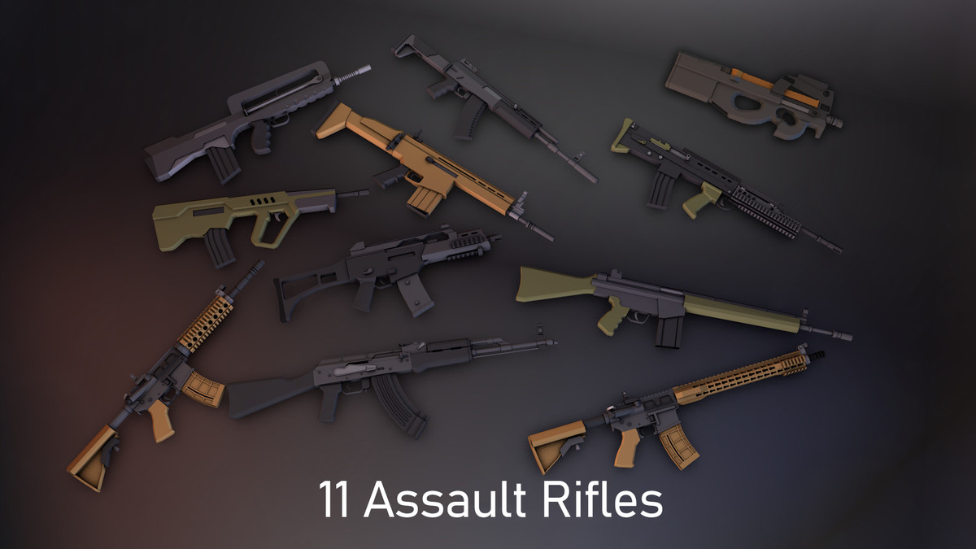
* Assault Rifle- Fast fire rate, Low Damage
* Revolver - Low fire rate, Medium Damage
* SMG - Fast fire rate, low damage
* Shotgun - Low fire rate - High Damage
* Sniper - Low fire rate - High Damage

**Dungeon Structure:**

* Low poly dungeon assets:

1. <https://assetstore.unity.com/packages/3d/environments/dungeons/low-poly-dungeons-lite-177937>

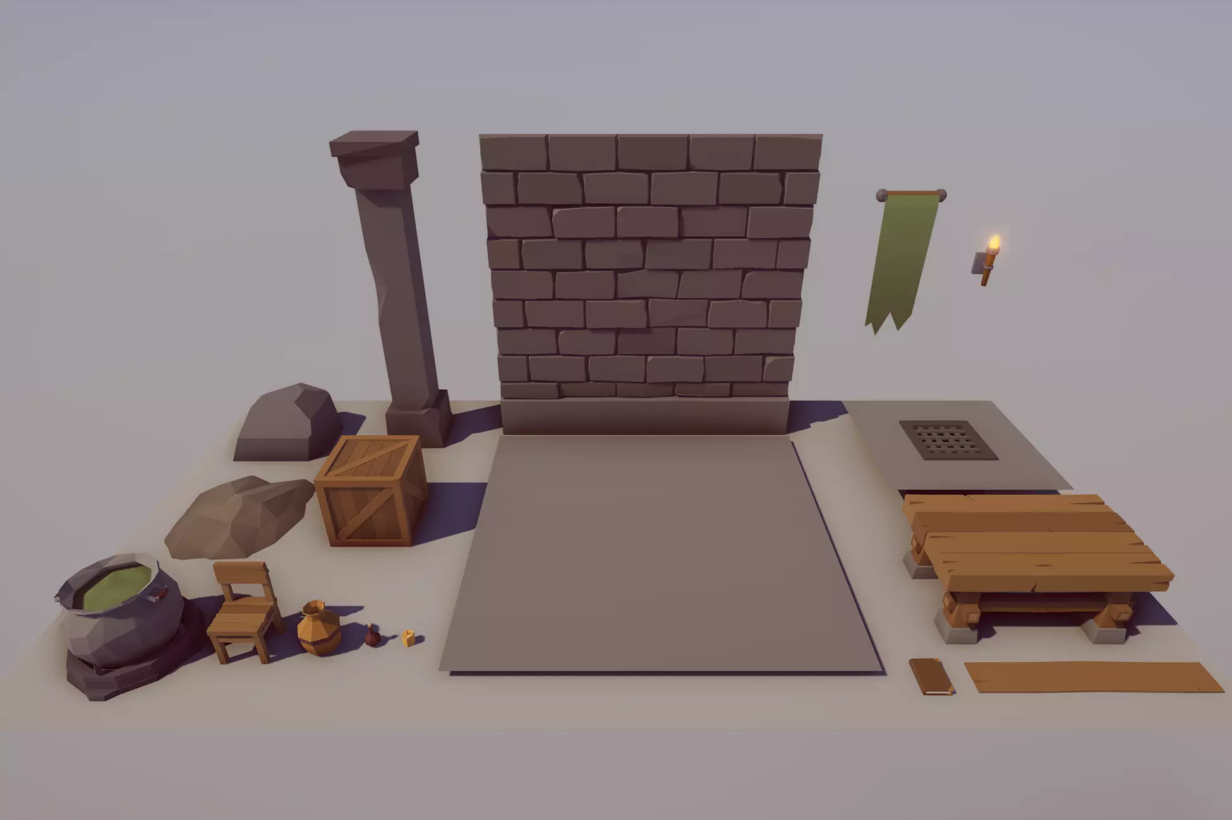

1. <https://assetstore.unity.com/packages/3d/environments/dungeons/ultimate-low-poly-dungeon-143535>

[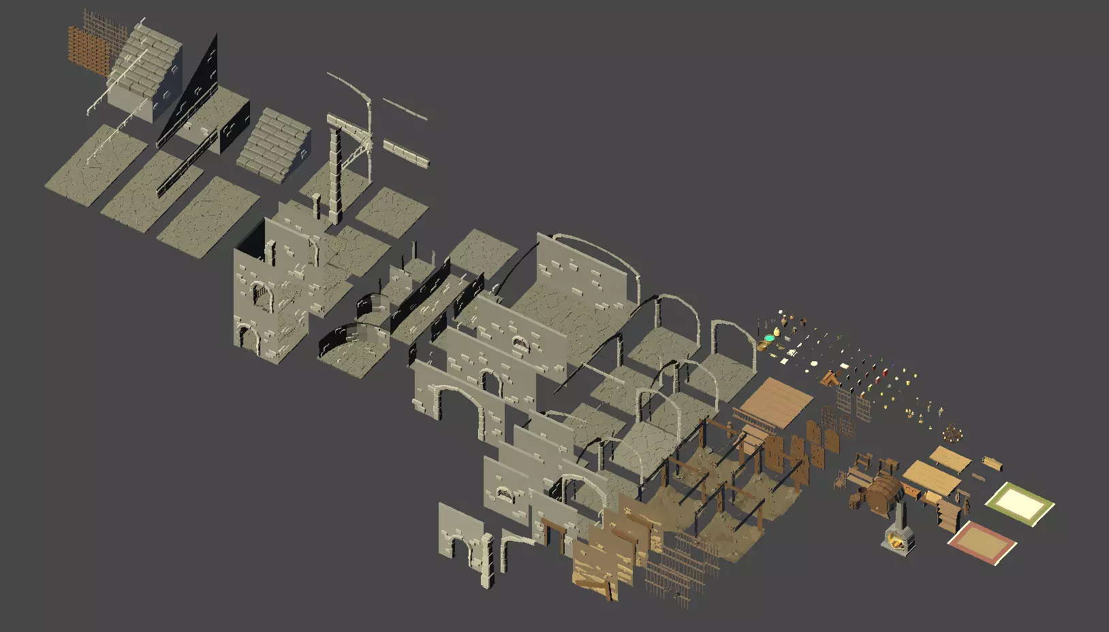](https://assetstore.unity.com/packages/3d/environments/dungeons/ultimate-low-poly-dungeon-143535)

1. <https://assetstore.unity.com/packages/3d/environments/fantasy/fantasy-treasure-pack-lite-80898>

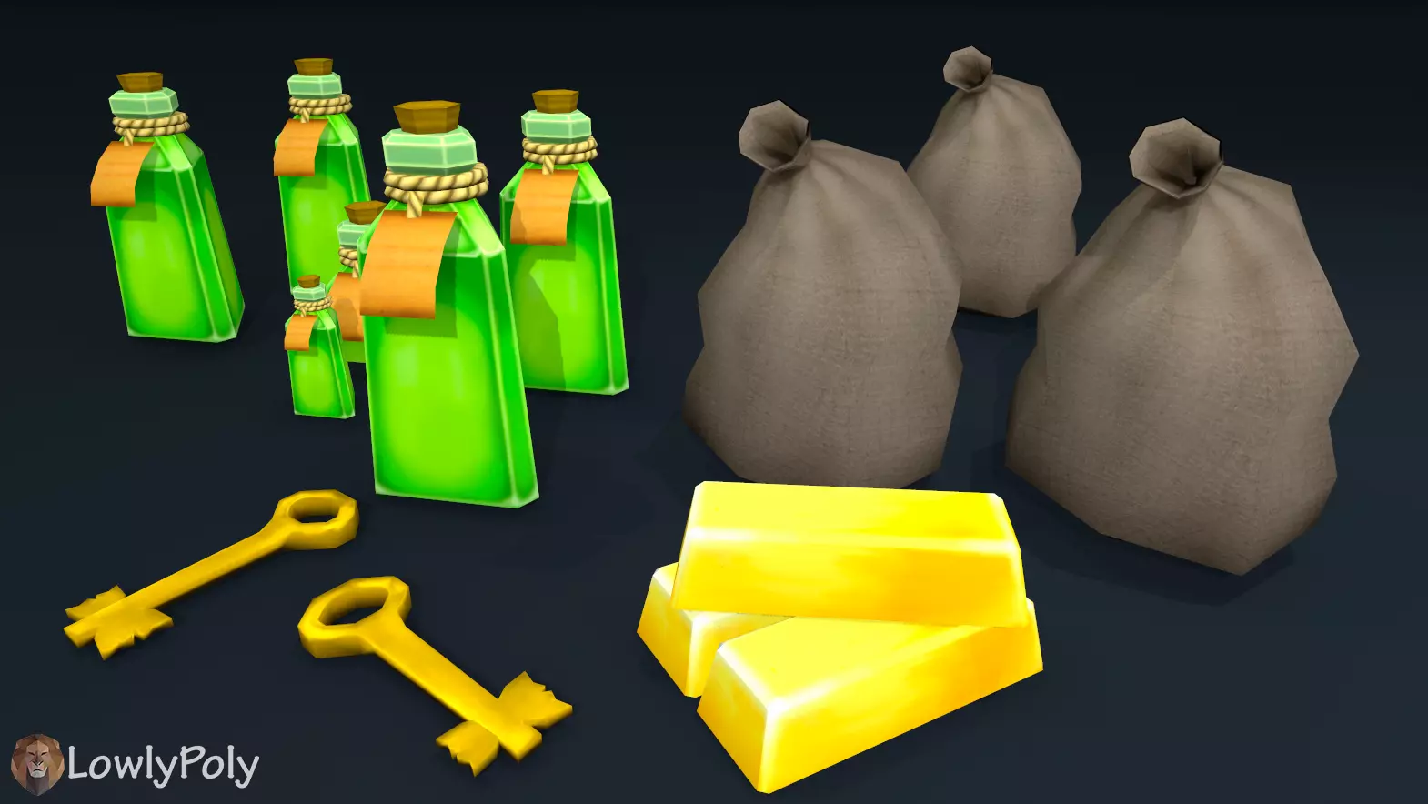

1. <https://assetstore.unity.com/packages/3d/props/chests-polypack-209167>

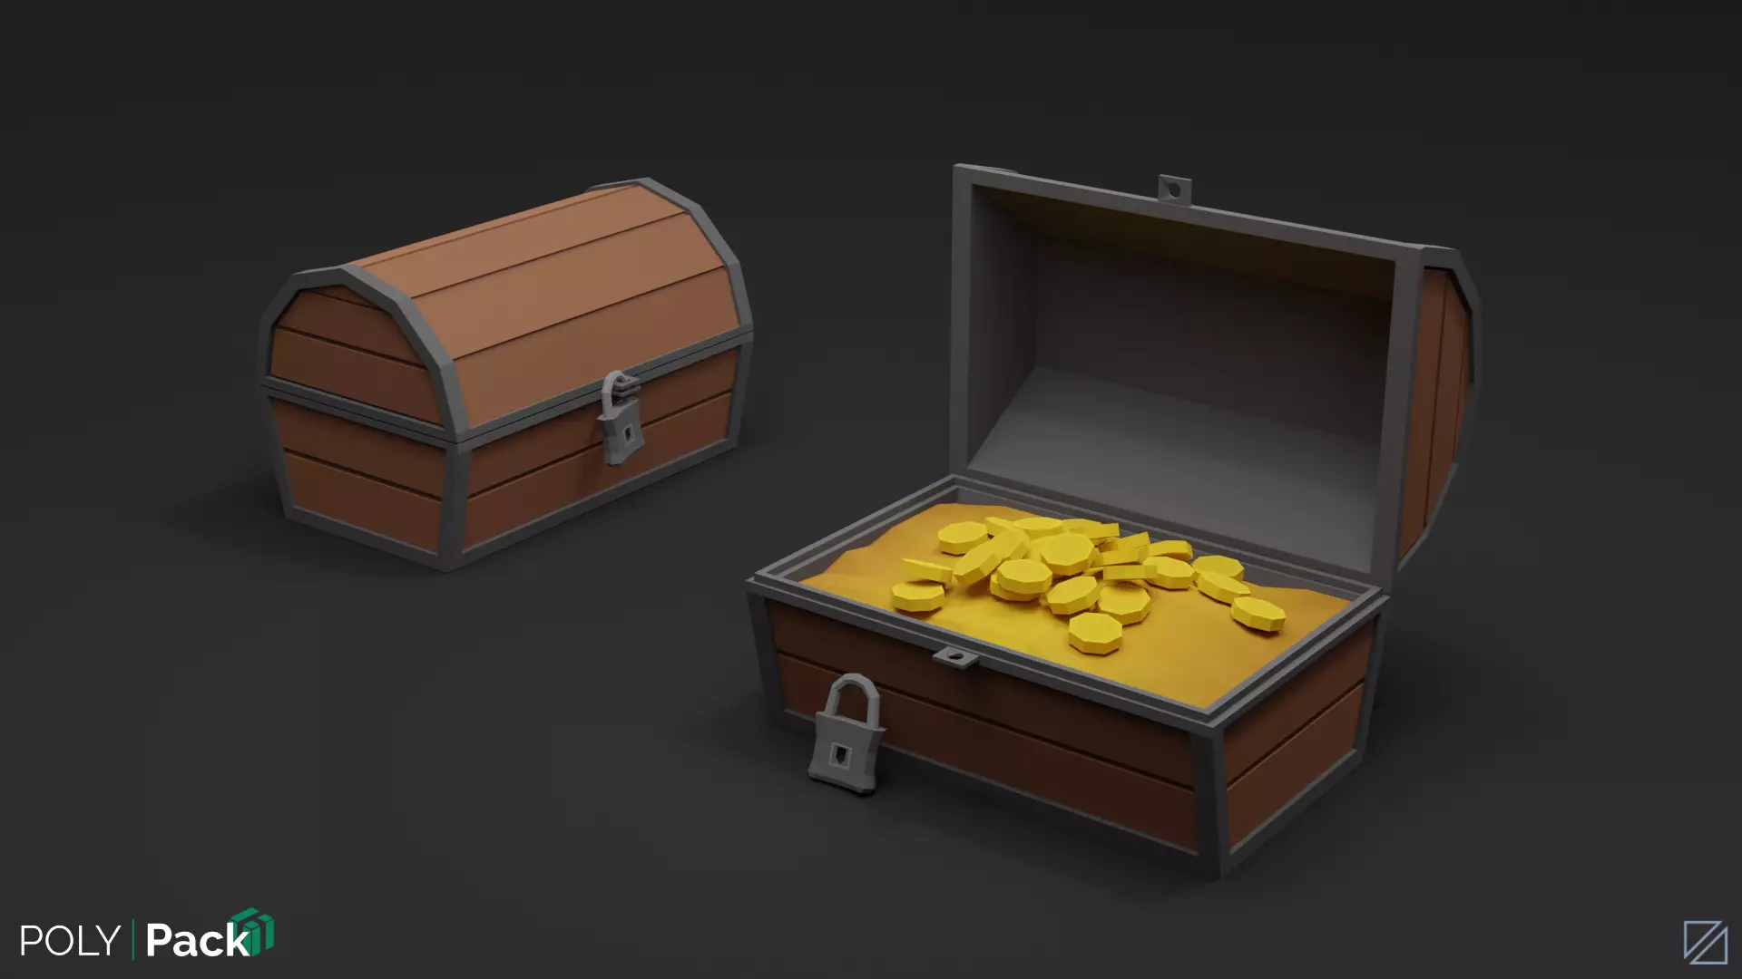

**UI/Menus:**

* On the top right of the screen, the player's health will be indicated by a health bar that depletes when they take damage.
  + The Player can recover health by acquiring Gems placed throughout the level
* On the top left there will be a counter displaying how much currency the player has acquired so far.
* To the left of the currency, is the key counter.
* On the bottom left of the screen will be an icon indicating the player's current weapon as well as their other weapons that they currently possess.
* The player will have a target reticle in the center of their screen. This will indicate where the player is currently looking as well as where they are currently aiming their weapon.
* Menus will include a play button, a history + controls button, and a settings button.
* Within the settings button, the player can adjust certain settings such as volume to the game.

## **Enemy Overview:**

**Final Boss (insert name here):** [**https://assetstore.unity.com/packages/3d/characters/insectoid-crab-monster-lurker-of-the-shores-20-animations-107223**](https://assetstore.unity.com/packages/3d/characters/insectoid-crab-monster-lurker-of-the-shores-20-animations-107223)

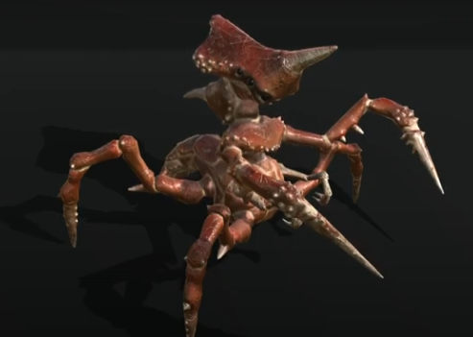

Attributes:

(1): Change attack range according to attack mode

(3): Shoot spike projectiles

(4): Accelerate move toward the player, causes physical collision damage

(5): High amount of HP

(6): Enemy most subject to change throughout development

**Little Spider:** <https://assetstore.unity.com/packages/3d/characters/animals/insects/animated-low-poly-spider-125114>

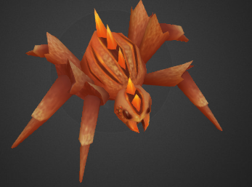

Attributes:

* The little spider will attempt to damage the player by making physical contact with them.
* The spider will begin to move at the player slowly, but will accelerate over time.
* To compensate for their fast movement speed, the enemy has relatively low Hp, but frequently appears in groups.
* Similar to the skeletons, larger variants can appear with larger health totals.

**Skeletons:**

<https://assetstore.unity.com/packages/3d/characters/creatures/undead-skeleton-enemies-192820>

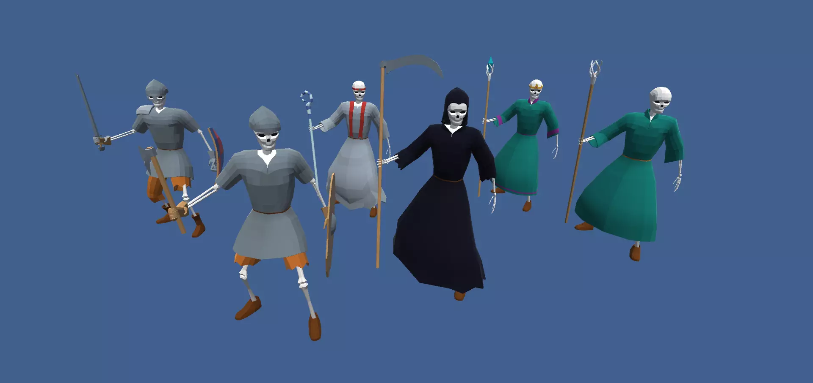

Attributes:

* Melee Skeletons
* Different Shapes of them (small and large variants)
* All of the various skeleton types move at the same speed
* Melee Wielding skeleton will attempt to walk towards the player and damage them through physical contact.
* Staff wielding skeletons do not exist, what are you talking about.

**Timeline and Milestones**

The following consists of our expected timeline and milestone, our-group will meet every Friday for at least half an hour to go over expectations for the following week.

**Week 1 (Mar 28 - Apr 3)**

Team members will research for their respective roles as well as overall game research. GitHub repository will be established as well as a designated Google Drive and discord for sharing game files.

**Week 2 (Apr 4 - Apr 10)**

The team will start working on the level design as well as creating a UI and main menu. Members will look for/create audio files we can use for the game.

**Week 3 (Apr 11 - Apr 17)**

Player and camera movement will be done.

The implementation of enemies will be done and the scripts for their movements will be started.

Will aim to have a good portion of the level design to be finished by this time.

**Week 4 (Apr 18 - Apr 24)**

Attempt to finalize the game this week, all scripts and level design should be finished by the end of this week. The main menu will be implemented

**Week 5 (Apr 25 - Apr 29)**

Tweaks to the final game will be made. Any missing attributes will be added. The final game will be tested and polished.

**TeamBio and Expected contribution fields**

**Daniel Levinthal (Co-Producer/Level Designer)**:

Daniel will be the main level designer/producer for the game. He is a third-year computer science major possessing a plethora of game design knowledge gained through watching informational videos and previous enrollment in game development courses. He has experience with coding in both C and Java, as well as a background in art through various outside courses. His contribution to the team will be locating or creating all necessary art assets and assembling the level environment together. He will also assist the programmers with code throughout the development process to ensure that development stays on schedule.

**Shaohang Song** **(Co-Producer/Character Designer):**

Shaohang will be the secondary designer/producer for the game. As a computing informatics major (was computer science) student, he has enough experience to perfect the interaction between players and the game. With his art background, he knows how to make the UI of the game look organized and user-oriented. The variety of gameplay types forms the foundation to be a good game designer. His contribution to the team will be creating the game characters such as the main player, and enemies, and connecting them with scripts to make a complete game experience. Moreover, creating a suitable UI for the game and various functions on the UI.

**Francisco Valdez (Programmer)**

Francisco will be the main programmer for the game. With sufficient programming background and game experience, he can easily complete most of the challenging code features and has the ability to debug. His contribution to the team will be writing programs that satisfy the requirements of the game. Completing the scripts function between game objects and users. The scope of scripts contains UI, enemy functions, and HUD programming.

**Zachary Lund “That’s mama Luigi to you Mario”** **(Co-Co-Producer/Programmer)**

Zachary will be the secondary programmer for the game. As a comprehensive game designer, he has a good understanding of all aspects and can work in a variety of teams. As an audio game producer before, he knows how to put things together in games. His contribution to the team will be supporting Francisco to complete and debug the required script and supporting Cole to figure out the audio problems if needed. And finish some parts of the scripts. The scope of scripts contains character functions, game controls

**Cole ( Lead Sound, music)**

Cole will be the lead sound designer for the game. As a sound designer, he understands how to work with sounds and edit them to fit the game’s tone and visuals. With a background as a sound designer and a wide array of game knowledge, he will know what sounds will fit best with the game. His contribution will be to produce and edit a majority of the sounds in the game. This includes movement sounds, attack sounds, damage sounds, death sounds, etc. Additionally, he will provide the music for the game, which are background music, combat music, and boss music.

**Post-Mortem:**

**Zacharias Ridgewell Lundellstington III**: I feel like that we had a vision and we executed it to the best of our ability. Our team struggled heavily with communication and collaboration due to our varied experiences and conflicting schedules. Our game turned out to be better than expected, with some shortcomings. The whole team procrastinated, some more than others. Lots of late nights were spent, more than there should have been. We somewhat got our act together, but at the end. I learned a lot about animation and how it interacts with code. I feel like all of my code works as intended, which I am proud of. From our original plan we had to change very little. We just had a bunch of rollbacks on ideas that we had previously pitched. Our level was scaled down, and we couldn’t implement a final boss or some other enemies in time. However, if I had to throw shade at a teammate, it would definitely be G. Ramsey. Man could NOT do his job. I couldn’t have asked for a worse teammate than the G man. Ram Ram was a let down for this team.

**Danielton “The Third” Levinthalenstein:** Our team had a rough start due to scheduling issues and personal conflicts interfering with our ability to work early on in the project. However, as time went on some of our group managed to band together to create what I would call a satisfactory final product. Near the end, we still had a few hiccups with certain mechanics not being implemented as expected. However, the teammates who banded together at the end managed to make the most out of what we had. Although Gordon Ramsey did not contribute much in the long run. For things that went right, I would say our game stayed relatively true to our original vision. For what went wrong, I would say our game is lacking a lot of the polish that would be expected from a long term project like this. We had to make a lot of compromises regarding the enemy variety and complexity, which in term had an effect on how complicated our level design could be. The biggest thing I learned is that large scale projects like this require constant communication throughout its entire duration, and that communication breaking down for even a little can have a snowball effect later down the road. I also learned that Gordon Ramsey does not make for a very good teammate.

**Gordon “Shigeru Miyamoto” Ramsay:** This game is within the top 15 games I have ever played. If It wasn’t for the fact that they used the luigi's mansion key sound effect I would request to publish this game myself. I single handedly cooked every asset that was used during the games development, and I know I can cook some damn good food. When I joined this team the food was raw, the lamb sauce was nonexistent, and there were no maidens. I changed all of that and turned this group around, and I couldn’t be more proud.

**Cole’s Weitzels Pretzels:** Given the circumstances and challenges our team had, I believe we executed the vision of our game to the best of our ability. Our main issues were just scheduling issues and lack of communication. But in the end we got our acts together and produced a satisfactory game for the given predicaments we had. For what went right for us, we stayed true to the original vision of the project. Additionally the level design, code, and sound design all work well for the most part. What went wrong was that there was not as much polish, due to previously mentioned issues and time constraints. We did have to have a few rollbacks, and could not finish some enemies in time. During this project I did learn a lot about sound design and editing. But the main lesson to take away from this is that constant communication is key for a group project. Having a communication breakdown can lead to an eruption of different issues, and have a snowball effect. Still, I believe that we put out a good project, given the situations we had.

**Franciscon Valdeeznuts:** While we started off our project wonky. I believe this team pulled together towards the end and my teammates did the best with what they had. Scheduling and communicating was the most difficult part as we had different schedules a lot of the time. What went right with our team was everyone delivered what was promised. Although we had a lack of communication at times, we still knew that everyone was expected to deliver. Something else that I believe that we did right was helping each other out. If a teammate was struggling there was always help offered, I was often on the being helped side of the spectrum; which I greatly appreciate my team for. The end product was nearly spot on to what we had originally planned which is something I’m proud of. From this project I learned that keeping the group updated is a key factor for creating a successful end product. I also learned a lot about AI, I still have skills to develop for it, but it was fun and challenging creating the scripts.



^giffendor

**Shaohang Song:** Working in a group allows people in different areas to try new things, and since many people have no experience in this area, most jobs need to be done as they learn. So I learned a lot about Unity game production, such as UI, game interaction, character creation, animator management, and so on. It's not just about making new things every day but also fixing code bugs that appear elsewhere. The completion time of the whole project was much longer than I expected. But we ended up with a good game. I want the player to experience our good intentions. GL and HF

**Credits:**

Gordon Ramsay - Everything, plus MORE, creation of the universe.

Zachary Lund - Primary Programmer/Gameplay Balance

Daniel Levinthal - Primary Level Designer/Gameplay Balance

Shaohang Song: UI, Secondary Programmer, and Menus

Francisco Valdez - Tertiary Programmer

Cole Weitzel - Lead Sound Designer

Sasquatch - “gruahhhhhhhhhhhh”

**Group Presentation Script:**

Daniel: The video game we are very happy to present today is called Road to Survival. It is the first of its genre, featuring a medieval setting…. but with GUns? Let us explain.

Zachar: So basically, you play as a time-traveler stuck in the past and you must explore the dark dreary dungeon to attempt to retrieve his precious time travel machine.

Cole: …

Daniel: The goal of the game is to collect 3 keys scattered throughout the dungeon, and then defeat the final boss using the equipment you collect along the way.

All around the dungeon are collectable weapons, gold bars, chests, and highly valuable gemstones.

Shaohang: In order to make players have a better game experience, our game UI style adopts dark elements with our final boss in the main menu, players can choose their own suitable game sound and mouse sensitivity through setting. The background and in-game weapon UI were created using PS software. The Animator script uses relatively simple logic to design, which makes programming easy and works well. The correct UI interaction is given to the player after death or winning the game, which shows the player's rank by comparing loots earned by the player with loot totals in the game. Getting the UI and enemies to interact with the player is challenging because we want to make a great game. The UI style is the first thing that lets players know about a game, rather than the game content.